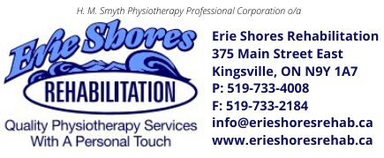
Are you a customer service rock star?
Join our award-winning team!
Our
If you love communicating & interacting with people to build relationships and want to work in a supportive, clinic environment that values its employees and their skill-development, let’s meet. The Erie Shores Rehabilitation team has an immediate need for a part-time Patient Experience Coordinator/ Office Administrator - 12-month contract but, for the right candidate, could lead to permanent part -time employment.

We offer you:
- Permanent, part-time work (25 hours/week to start)
  - Flexibility to cover vacation or sick days with an 8 am start and/or 6 pm finish is required
- $18-20/hour
- A positive clinic culture where we support you and value your input
- Development courses that help build your skill-set
- Paid onboarding and training
- Company sponsored team meals and outings
- Career options:
  - Focus on being amazing at patient experience and administrative duties
  - Fill a second role as marketing lead and/or chief culture lead
Are you:
- Persistent in your drive to be a patient champion and provide customer service excellence
- Productive in a fast-paced environment where adaptability, resilience and multitasking are a must
- An effective communicator with polished in-person, written, phone and email etiquette
  - Able to explain the value of our services and set us apart from others
- Organized and resourceful, as a self-directed independent worker and as part of a team
- A detective when it comes to attending to details and problem solving
- Able to calmly manage and address client issues and concerns
- Confident with Microsoft Office and Google productivity software, social media platforms, Canva & Hootsuite or similar, and clinic management software

Preferred skills:

- Experience in a healthcare clinic
- Understanding of WSIB
- Healthcare billing through Telus and HCAI
- Juvonno EMR software or similar

Contact me if you have the same CORE VALUES:
- You strive to provide outstanding client-centred customer service to clients and administrative support to the clinical team
- You want to contribute to a vibrant atmosphere as part of a team of administrative and health care professionals
Send your resume, complete with cover letter describing how you prepare and eat a bowl of cereal to reweston49@gmail.com

