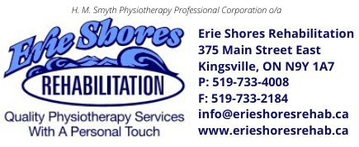
There’s a full Physiotherapy caseload waiting for you.
Join our award-winning team and work in a supportive, fun environment!

Erie Shores Rehabilitation has an immediate opening for a full-time Physiotherapist.
Experienced PTs, Residents and New Grads all encouraged to apply.

Erie Shores Rehabilitation is a well-established, physiotherapist-owned, private practice located in Kingsville, Ontario, on the shores of Lake Erie. We have provided health care services to our thriving and growing community for over 25 years. As a team, we won the Community Votes Windsor Platinum Award for Physiotherapy and Rehab Clinics in 2021, 2022 & 2023. and the Town of Kingsville Business of the Year Award in 2020. When you’re not working at the clinic, explore the region on bike, foot, kayak, paddleboard or by boat and enjoy the local gastropubs, wineries, and craft breweries and distilleries.
We offer you:
- 1:1 treatment with 60-min assessments and 30-min treatments. No double-booked sessions.
- Clinic marketing, an established reputation and referral sources to build and maintain your caseload
- Full administrative support. We manage all reception, appointments, invoicing, and billing for you
- Your own private office/assessment room and designated treatment space in the bright, spacious gym
- Scheduled weekly meetings with an experienced PT to problem solve difficult cases, practice techniques and review caseload management, patient engagement and communication skills to get even better outcomes
- Hourly compensation with vacation and statutory holiday pay
- Health benefits
- $1000 annual education allowance
- Paid subscription to the clinician education site Embodia
- Monthly staff meetings and interprofessional sessions
- Company sponsored lunches and team activities

Contact us if you have the same CORE VALUES:
- You’re focused on helping your patients reach their treatment goals
- You embrace on-going learning and professional development
- You want to contribute to a positive team atmosphere

Required Competencies:
- Registered member in good standing with the College of Physiotherapists of Ontario

If this position interests you, send your resume to heather@erieshoresrehab.ca and we’ll be in touch soon.

